XpertBot Academy Internship

### 

### 

### **Xpertnurse**

Objectives: Extract insights, Build models, and Create data-driven solutions

Intern: Israa Hmadi

Email: [israa.al.hmd@gmail.com](mailto:israa.al.hmd@gmail.com)

# Phase 1:

## ERD:

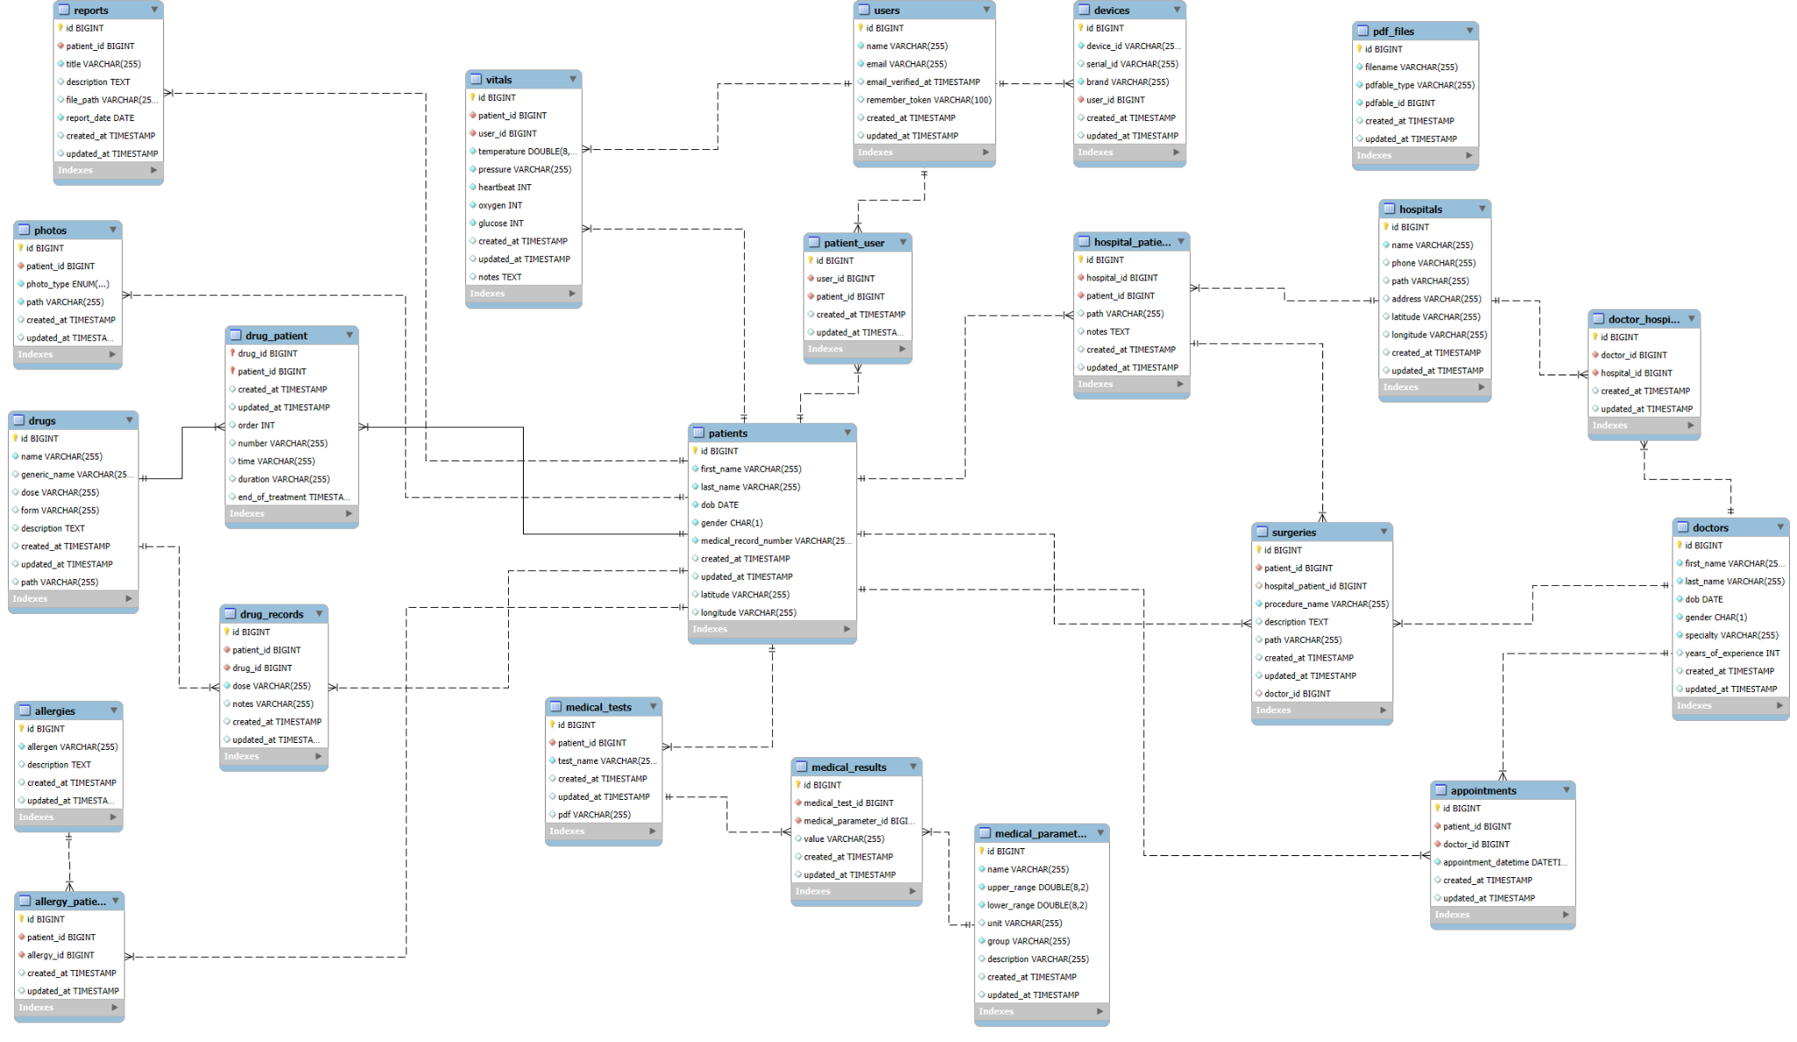

## Data profiling - Analyzing patients, medications, vitals, visits data

Analysis is available on github in phase 1 codes.

## Schema documentation - Map relationships in healthcare data model

Tables and their relations:

## **1. Users**

* One user → many devices (devices.user_id)
* One user → many vitals (vitals.user_id)
* Many-to-many with patients via patient_user

## **2. Patients (Central Entity)**

* **Vitals** – One patient → many vitals (vitals.patient_id)
* **Drug Records** – One patient → many drug administration records (drug_records.patient_id)
* **Drug–Patient relationship** – Many-to-many with drugs via drug_patient
* **Allergy–Patient relationship** – Many-to-many with allergies via allergy_patient
* **Photos** – One patient → many photos (photos.patient_id)
* **Reports** – One patient → many reports (reports.patient_id)
* **Surgeries** – One patient → many surgeries (surgeries.patient_id)
* **Medical Tests** – One patient → many medical tests (medical_tests.patient_id)
* **Appointments** – One patient → many appointments (appointments.patient_id)
* **Hospitals** – Many-to-many with hospitals via hospital_patient
* **Users**- Many-to-many with usersvia patient_user

**3. Drugs**

* One drug → many drug records (drug_records.drug_id)
* Many-to-many with patients via drug_patient

## **4. Drug–Patient (drug_patient)**

* Join table for many-to-many between patients and drugs.

## **5. Drug Records (drug_records)**

* One patient → many drug records
* One drug → many drug records

## **6. Hospitals**

* Many-to-many with patients viahospital_patient
* Many-to-many with doctors via doctor_hospital

## **7. Hospital–Patient (hospital_patient)**

* Many-to-many join table between hospitals and patients.
* One-to-many with surgeries: hospital–patient record → many surgeries (surgeries.hospital_patient_id)

## **8. Doctors**

* One doctor → many appointments (appointments.doctor_id)
* Many-to-many with hospitals via doctor_hospital

## **9. Doctor–Hospital(doctor_hospital)**

* Join table for many-to-many between doctors and hospitals.

## **10. Appointments:**

* One patient → many appointments (appointments.patient_id)
* One doctor → many appointments (appointments.doctor_id)

## **11. Medical Tests**

* One patient → many medical tests (medical_tests.patient_id)
* One medical test → many medical results (medical_results.medical_test_id)

## **12. Medical Parameters**

* One medical parameter → many medical results (medical_results.medical_parameter_id)

## **13. Medical Results**

* **Many-to-One with Medical Tests** – One medical test can have many medical results (medical_results.medical_test_id)
* **Many-to-One with Medical Parameters** – One medical parameter can be associated with many medical results (medical_results.medical_parameter_id)

## **14. Reports**

* One patient → many reports (reports.patient_id)

## **15. Allergies**

* Many-to-many with patients via allergy_patient

## **16. Allergy–Patient (allergy_patient)**

* Join table for many-to-many between patients and allergies.

## **17. Surgeries**

* One patient → many surgeries
* One hospital–patient record can have many surgeries
* One doctor → many surgeries (surgeries.doctor_id)

## **18. Photos**

* One patient → many photos (photos.patient_id)

## **19. Devices**

* Belongs to a user (devices.user_id)

## **20. PDF Files**

* Currently not linked to other entities in the healthcare schema.

## **Note: Tables Excluded from Medical Schema**

These are system/Laravel-related tables and not part of the healthcare domain model:

* migrations
* password_resets
* personal_access_tokens
* failed_jobs
* telescope_entries
* telescope_entries_tags
* telescope_monitoring
* action_events

**Other Phases:  
The code of phase 1 and other phases is found in the repository**